Commodore C64 Power Supply (Replacement) Rev. 2

Module Description

This module is a power supply unit for the Commodore C64. It is dimensioned for an input voltage of 230VAC and provides 9VAC@2A as well as +5VDC@2A, which is sufficient to power the C64. The output voltages are isolated against each other.

The dimensions of the PCB are suitable for fitting it into an RND 455-00220 plastic enclosure (reichelt.de).

The PE connector is not connected to the mounting holes. In case a metal case is used, a 3 prong mains connector is mandatory and the case has to be connected to PE.

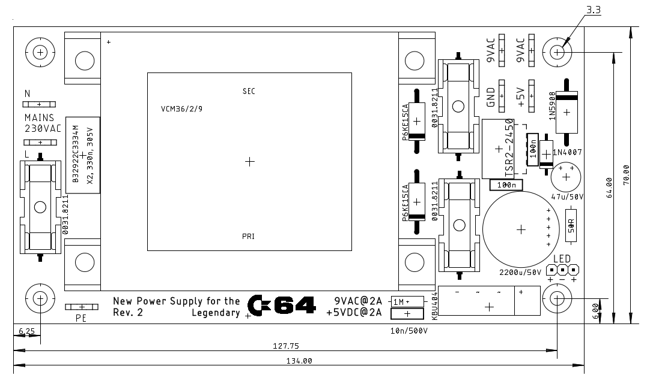

Figure 1: Dimensions of the PCB

# Pinning

### Spade connectors

6,3 x 0,8

|  |  |
| --- | --- |
| Spade connector | Voltage |
| J1 | Mains (L) |
| J2 | Mains (N) |
| J8 | PE (not assembled) |
| J4 | 9VAC (1) |
| J5 | 9VAV (2) |
| J6 | +5V |
| J7 | GND (reference for +5V) |

## LED

A blue LED (Vf=4,0V @ 20mA) is connected to J3. J3: Pinheader, RM2,54mm.

|  |  |
| --- | --- |
| Pin | Signal |
| 1 | LED+ |
| 2 | LED- |
| 3 | LED+ |

For a red, green or yellow LED, the value of R1 should be 330Ω.

## Fuses

|  |  |  |
| --- | --- | --- |
| Fuse | Voltage | Value |
| F1 | 9VAC | 2AT |
| F2 | +5VAC | 2AT |
| F3 | Mains (230VAC) | 0,16AT |

# Revision History

## Rev. 0 → Rev. 1

* PCB revision
* C5: footprint corrected
* D4: diode added

## Rev. 1 → Rev. 2

* PCB revision
* IC1: TRACO 2A version (it is still possible to place the RECOM 1.5A dc/dc converter).
* D1: different type
* J8, R2, C6: Experimental connection of GND and PE